1.
Draw and label a simple home network diagram showing a router, switch, and three devices (like a laptop, smartphone, and smart TV), indicating how each device connects to the network.
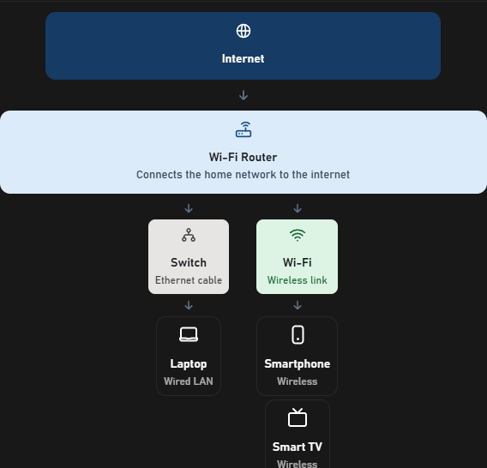
2.
Create a comparison table listing at least four network devices (router, switch, hub, access point) and describe one real-world use case for each, referencing apps or services you use daily (e.g., WiFi for streaming on YouTube, LAN gaming, etc.).
Network Device | Main Function | Real-World Use Case
Router | Connects different networks and forwards IP packets | Connecting home devices to the internet to order food on Zomato
Switch | Connects devices in a wired LAN | Connecting gaming PCs for LAN gaming or sharing files
Hub | Broadcasts incoming data to all other ports | Demonstrating basic network communication in a small networking lab
Access Point (AP) | Allows wireless devices to join a wired network | Connecting a smartphone to Wi-Fi to watch YouTube
Modem/ONT | Connects the home network to the ISP's access network | Bringing a broadband or fiber internet connection into the home

3.
Write a short scenario where you explain how data travels from your phone to the internet when you order food on Zomato, mentioning the role of each network device involved (router, switch, access point).
Step 1 — Smartphone
You select the food and tap Place Order. The app creates a request containing the order details.
Step 2 — Access Point and Router
Your phone sends data over Wi-Fi to the router's built-in access point. The router forwards the IP packets towards your internet service provider (ISP).
Step 3 — Switch (if present)
Ethernet switches forward frames between connected devices in the local network. A separate home switch is not necessarily involved in your phone's internet traffic.
Step 4 — ISP and Internet
The ISP carries the packets through its network and other internet networks to the appropriate Zomato server.
Step 5 — Server Response
Zomato processes the request and returns an order confirmation. The response travels back through the internet, router and Wi-Fi connection to your phone.

4.
Given this situation: you have a WiFi router, but your gaming PC only has an Ethernet port and is far from the router. Suggest two different network devices you could use to connect your PC to the internet and explain how each would work in this setup.<br><br><em><strong>Hint:</strong> Think about devices like switches, powerline adapters, or WiFi extenders.</em>

Option 1: Powerline Adapter
- Plug one adapter near the router and connect it using an Ethernet cable.
- Plug the second adapter near the gaming PC and connect it to the PC's Ethernet port.
- The adapters carry network data through the home's electrical wiring.
Best for: A distant room where running a long Ethernet cable is difficult.
Limitation: Speed and latency depend on the home's electrical wiring.
Option 2: Wi-Fi Extender with Ethernet Port
- Place the extender where it receives a good Wi-Fi signal from the router.
- Connect the gaming PC to the extender using an Ethernet cable.
- The extender receives data over Wi-Fi and forwards it to the PC through Ethernet.
Best for: Rooms where a suitable Wi-Fi signal is available but the PC has no Wi-Fi adapter.
Limitation: Wireless interference and extender quality can affect gaming latency

